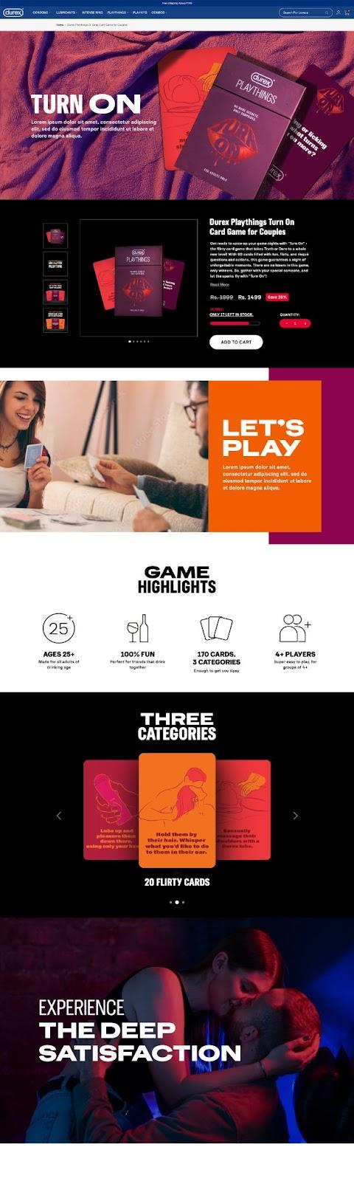 

Cards to be used for the Section.  
Drive link: <https://drive.google.com/drive/folders/1POTq62843zDtUtOcaAhX10orzay3IbYo?usp=sharing>

Fun Cards: Caption: 20 Fun Cards to spark the romance

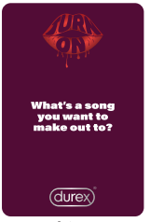 

Flirty Cards: Caption: 20 Flirty Cards to get up close and intimate

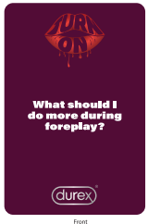 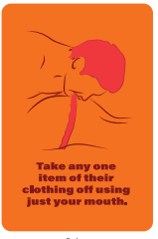

Risqué Cards: Caption: 20 Risqué Cards to drive each other wild

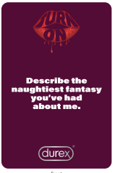 

Game Highlights Section:

<https://www.flaticon.com/free-icon/card_7998218>  
Caption: 3 Levels, 60 Cards  
  
<https://www.flaticon.com/free-icon/21_10490386>   
Caption: For Adults Ages 21+

<https://www.flaticon.com/free-icon/multiplayer_747285>   
Caption: Crafted for Couples

<https://www.flaticon.com/free-icon/holidays-party_12012322>  
Caption: 100% Fun

Video Link and Content:

Next Section:  
Caption: Shop Our Bestselling Combos  
  
Combos of Turn On will come here <Commerce Section>

FAQs Section